19 November 2025
Dear Families
Attendance Matters
As we head into the second half of the Autumn Term and the days become colder and darker, we’d like to thank you for your continued support in helping make Lincroft Academy a place where every child feels they belong and can flourish. We’d also like to remind you how to report absences, lateness, or appointments during the school day.

Last year we saw changes to attendance law and statutory guidance (The School Attendance (Pupil Registration) (England) Regulations 2024) and Working Together to Improve School Attendance). Thankfully, there are no new updates this year, allowing us to focus on embedding our support-first approach working together to resolve barriers to attendance and ensure every child can access their education.

Our Vision
We aim to build a culture of belonging, where children and families feel supported. We use attendance information to guide early action, celebrate successes, and offer help when needed. Positive relationships are at the heart of this. We know that sometimes there can be barriers to attending school and we want to ensure it can be made as easy and positive as possible.

A Reminder of What the DfE Guidance Means:
We must:
- Have a Senior Attendance Champion in the academy (Jodie Attreed, Vice Principal) and publicly advertise an attendance policy (we also have a pupil-friendly version available to aid understanding on our website), to ensure you are aware of expectations, processes and legal actions that can be taken (although we always hope to avoid that where possible).
- Promote a whole-school culture where attendance is everyone’s responsibility and train staff know their role, build relationships, promote inclusion, understand sharing of information and working together (with parents, other schools, local authorities, health etc.).
- Record registers accurately and not keep the registers open longer than 30 minutes after opening; late arrivals after that must be marked absent (students must sign in to be counted for fire registers).
- Identify and explore all absence before, or when, it reaches 10 unauthorised absences in 10 school weeks (the National Framework) and offer early support if needed via reasonable adjustments, support plans and attendance contracts to nurture, support, resolve barriers to attending school and promote well-being.
- Only authorise absence that is requested in advance and that is for exceptional circumstances (absence for the purpose of holidays, recreation or leisure do not generally meet that criteria and, if taken, carries an automatic consideration of legal action).
- When support does not lead to improved attendance, formally warn parents that consideration of either intense statutory support or legal action will happen, e.g., a Penalty Notice Fine or Court Prosecution or Family Court Order.

How You Can Help
- Report absences promptly by emailing attendance@lincroft.academy. Please provide medical or appointment evidence when needed.
- Schedule appointments outside school hours wherever possible and ensure your child signs in/out if they must leave during the day.
- Communicate openly with us if there are barriers to attendance or ongoing health issues—we are here to help.
- Plan absences outside term time and submit any exceptional requests in advance if possible.

When Your Child Feels Unwell
We understand that children may occasionally feel unwell during the school day. We have a process in place to support students if this occurs:
- Students visit the first aid room for assessment.
- Students may be monitored for a period by school staff before a decision is made to send a child home.
- Students will be sent home if they are clearly unwell.

Please support us by ensuring that if your child contacts you directly to say they feel unwell, you ask them to go to the first aid room for assessment; mobile phones should not be seen or used during the school day. We will always act quickly and compassionately for genuine illness or injury, and our staff will ensure your child’s health and safety remain a priority.

Working Together
Thank you for your continued support in promoting good attendance and well-being. Regular attendance supports both learning and resilience. For any questions, please contact your child’s House Team or the Attendance Team. Further resources are available on our Trust website: Attendance - Meridian Trust

Warm regards,
Jodie Attreed
Vice Principal, Senior Attendance Champion

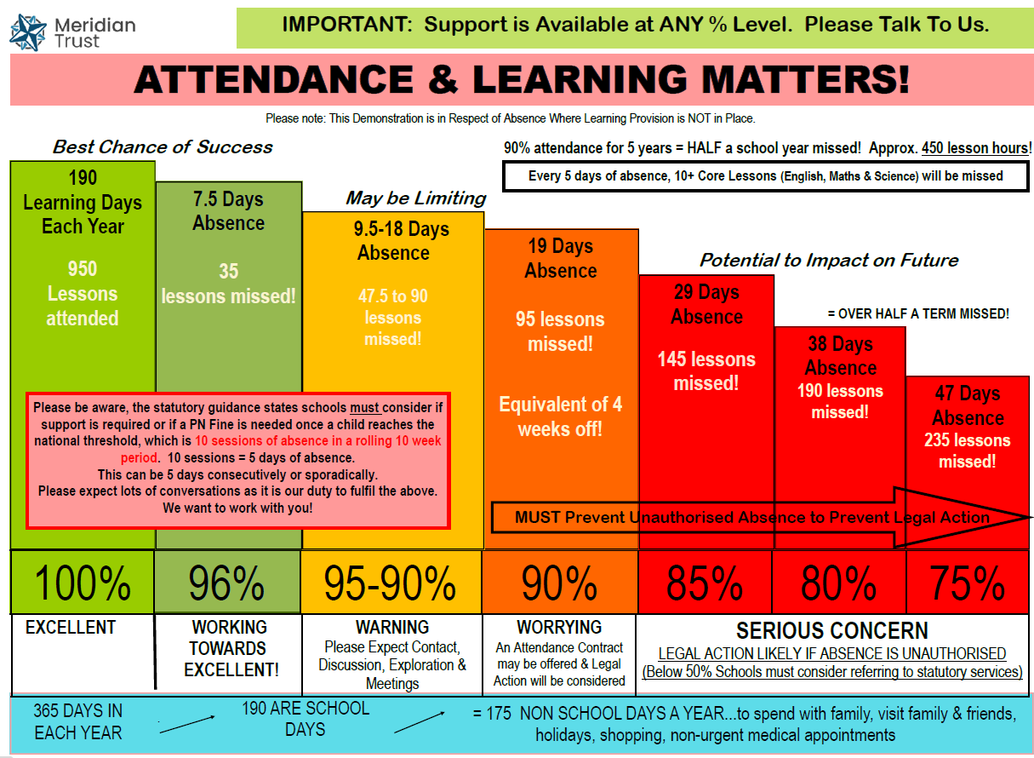
Graph Explanation:
- We do not use a specific % level alone when identifying which children may need support for their attendance but we recognise that an overall % can act as a guide to whether an action may be needed, thus triggering exploration.
- The below graph demonstrates what an annual % means in terms of lessons (learning) missed to give some context, and how the % level may be of concern.
- Please note, this graph does not distinguish between authorised and unauthorised absence, so if a child has, for example, 80-85% attendance due to a medical condition or specific need, and this has been recorded as authorised absence, those circumstances will lower the ‘concern’ level, opposed to if the absence was all unauthorised. However, it would not lower the requirement for discussion and support that is needed for all absence.

